KTR Structural Analysis

Purpose
This document summarizes the structural analysis results for the CIRFLINK CubeSat which will be deployed from the JEM Small Satellites Orbital Deployer (J-SSOD)

Applicable Document
- JX-ESPC-101133-D JEM Payload Accommodation Handbook, Vol 8. Small Satellite Deployment INterface Control Document
- JMX-2012694 Structural Verification and Fracture Control Plan for JAXA Selected Small Satellite Released from JSSOD

1.5U Structural Analysis

Structural Design
The CIRFLINK satellite structure is a 1.5U design made of four frames, a top plate, bottom plate, and four cross frames. The structural components are made from aluminum 7075 - T6 alloy. The internal subsystems are mounted on the primary structure with the aid of 4 aluminum rods and aluminum spacers. Figure 1 shows the external view of the satellite. Figure 2 shows the primary structure of the satellite. Table 1 shows the parts list of CIRFLINK. Table 2 shows the list of fasteners. Table 3 shows the safety critical parts of the satellite.
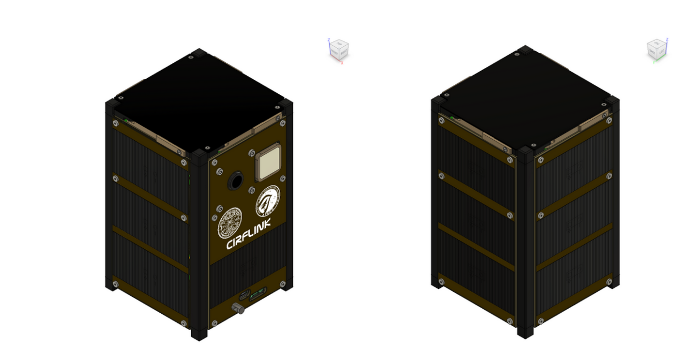
Figure 1. Overview of CIRFLINK

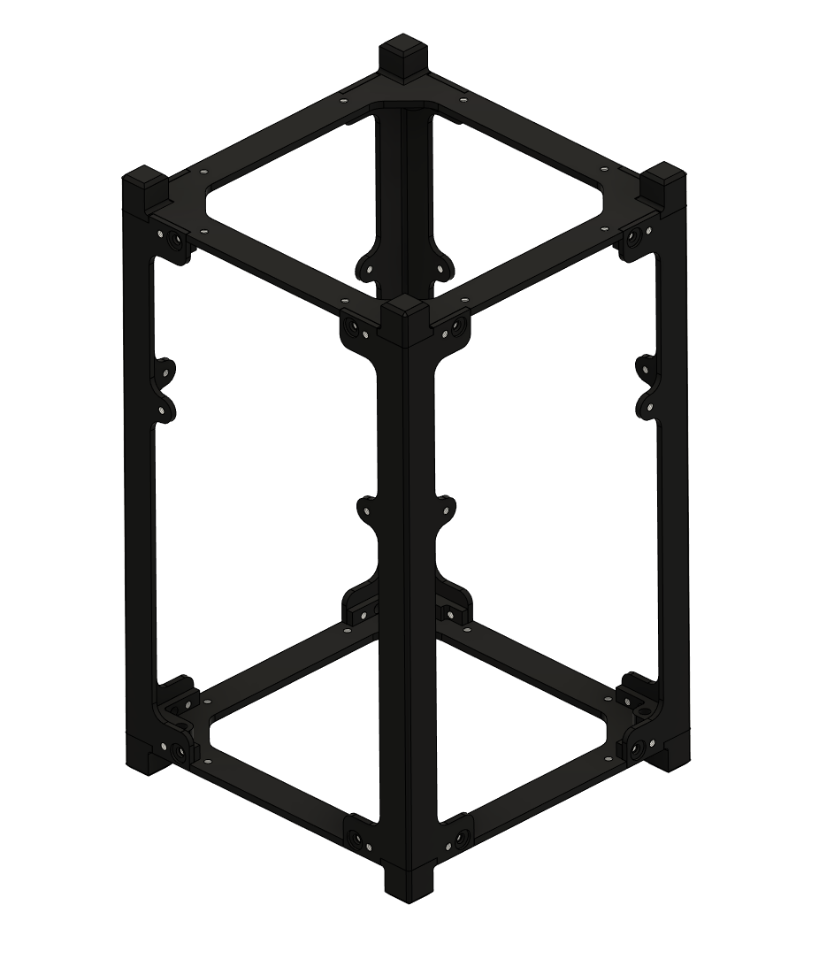
Figure 2. Main Structure of CIRFLINK
Table 1. CIRFLINK: Parts List
Item | Part Description | Part no | Material | Remarks
Top Plate |  |  | A7075
Bottom Plate |  |  | A7075
Frame +Y-X |  |  | A7075
Frame +Y+X |  |  | A7075
Frame -Y+X |  |  | A7075
Frame -Y-X |  |  | A7075
Spacer Axis |  |  | A6061-T6
EPS |  |  | A7075
MTQ |  |  | A7075
COMM-OBC |  |  | A7075
Payload
Dep. Antenna |  |  | PEEK
Panel -Z |  |  | FR4
Panel +Y |  |  | FR4
Panel -Y |  |  | FR4
Panel +X |  |  | FR4
Panel -X |  |  | FR4
Battery
Battery
Camera Module
Ext Port (RBF)
Kill Switch

Table 2. List of Fasteners
Item No | Description | Material | Grade | Quantity | Remarks
1. | M2 | SUS304 | SUS304
2. | M2.5 | SUS304 | SUS304

Table 3. Safety Critical Parts on CIRFLINK
Item No. | Description | Material | Quantity | Covered (Yes/No) | Remarks
1. | Camera lens | Glass | 1
2. | Solar Cell Cover | Glass | 10
3. | Battery Cell
4. | Deployment Mechanism
5. | Wire*
6. | Fasteners

Analysis Model
This analysis was performed using Autodesk Fusion 360 software, program version 16.10.0.2252.

Mass Characteristics
The mass of CIRFLINK computed from the FEM model is 1.98 kg. The center of mass of CIRFLINK is shown in Table 4. The coordinate system of the J-SSOD satellite install case is used, and the mass center is shown with the origin (x = 0 mm, y= 0 mm and z = 0 mm) set at the base of the minus Z rail standoff. According to the payload accommodation handbook, the center of gravity of the satellite shall be located within a cylinder with a radius of 20 mm centered on the Z-axis.

Table 4. Mass center of CIRFLINK
 | X-axis | Y-axis | Z- axis
Geometric center | 0 mm | 0 mm | 85.1 mm
Mass center | 1.27 mm | 4.05 mm | 77. 76 mm

Finite Element Modeling (FEM)
The CIRFLINK satellite was modeled using Autodesk Fusion 360. The FEM has approximately the same mass as the CAD model. To simplify the model, complex geometry such as filets and chamfer that do not significantly impact the results were suppressed. The fasteners models were simplified by removing the thread profile.

Static loads analysis and normal modes analysis were performed.

Natural Frequency
A modal survey was conducted with the plus and minus Z standoffs fully constrained. The fasteners were simplified like in the static analysis. No load is applied in the modal analysis. The normal modes and mass participation factors are listed in the table below. The principal modes in the X, Y, and Z axis are shown in the figures below.

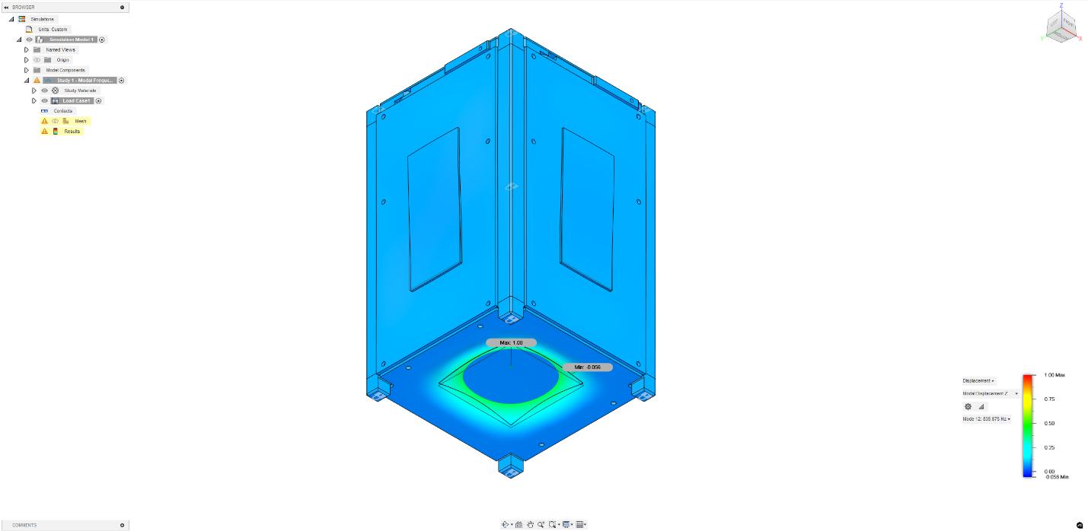
Natural frequency, 501.175 Hz (Principal mode in Z- axis)

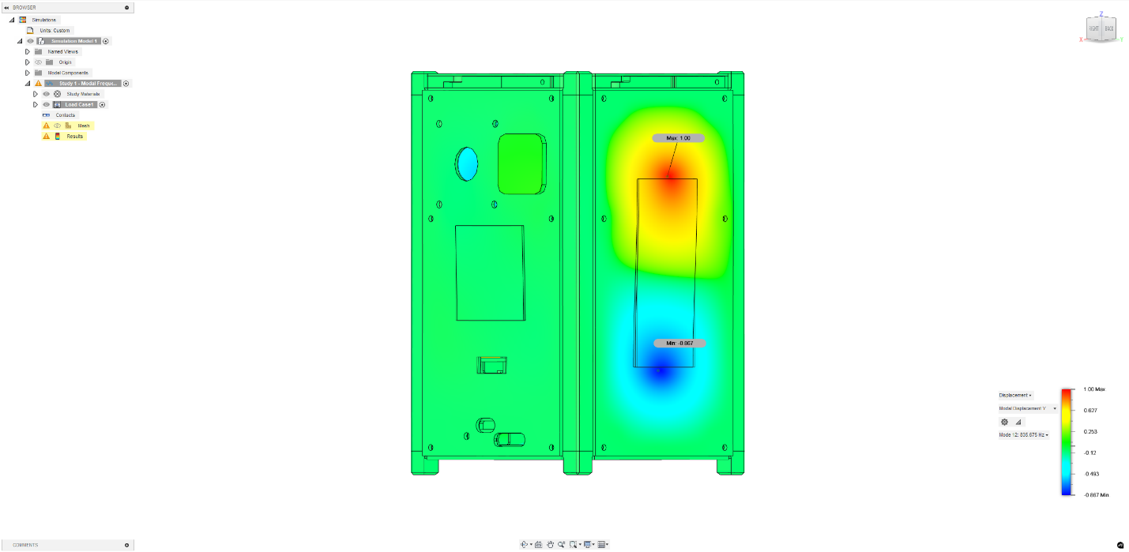
Natural frequency, 437.428 Hz (Principal mode in Y-axis)

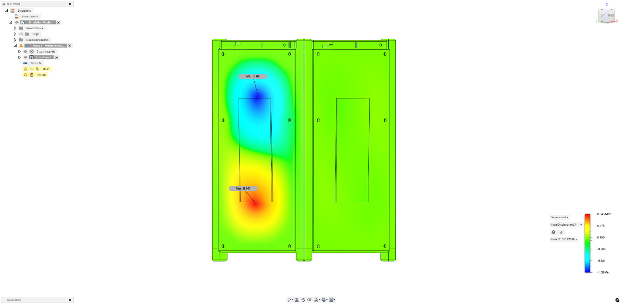
Natural frequency, 512.898 Hz (Principal mode in X-axis)

Table of Modal frequencies and mass participation
Mode | Frequency (Hz) | X | Y | Z | Principal mode
1. | 437 | 0.0336 | 0.3674 | 0 | Y
2. | 501 | 0 | 0.0016 | 1.1765 | Z
3. | 512 | 3.8258 | 1.8009 | 0 | X

Static Load Analysis
The fasteners were preloaded by applying a tensile force corresponding to the bolt preload for the specific fastener size on the bolt head (Table X). A bonded contact setting was used between the bolt head and the clamped surfaces, between two adjacent clamped surfaces, a separation contact was used. The model was fully constrained on the rail standoffs in minus Z direction. The case and loading conditions are shown in Table Y.

The margin of safety for each analysis case was calculated using the following equation.

$$Margin of Safety (MS)= \frac{Allowable Stress}{Max Stress (Smax) x Factor of Safety (FS)}-1$$

The primary structure must also satisfy the requirement
$$\frac{Smax}{Ftu}< 30 \%$$
Where $S_{max}=$ maximum applied stress (MPa)
$Ftu=$ Ultimate strength of the material (MPa)

Table X. List of fasteners and preload used on CIRFLINK
Fastener Type | Nominal diameter (m) | Initial Torque (Nm) | Preload (N)
M2 | 0.002 | 0.088 | 440
M2.5 | 0.0025 | 0.180 | 720

Table Y. Static Analysis: Loading Cases
 | X axis | Y axis | Z-axis | Compressive load
Case 1 | -- | - | 9 G | 46.6 N
Case 2 | 9 G | - | - | 46.6 N
Case 3 | - | 9G | - | 46.6 N
1G = 9.81 m/s^2

Case 1
The Maximum Von mises stress = 250.183 MPa. The stress distribution in the satellite parts is shown below
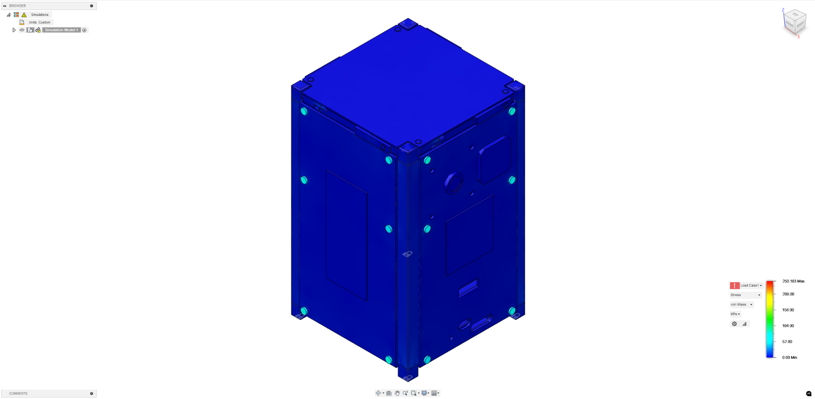
Maximum Von mises stress = 250.183 MPa, Load Case 1

Table. Satellite parts stresses and Margin of Safety (Case 1)
Part | Material | Smax (MPa) | Yield strength (MPa) | Ultimate Strength (MPa) | MS (yield)  FS = 1.5 | MS (Ultimate)  FS = 2 | Smax/Ftu (%)< 30%
Str_Base | Al7075 | 74.8 | 480 | 540 | 3.3 | 2.6 | 13.9
Str_Top | Al7075 | 101.8 | 480 | 540 | 2.1 | 1.7 | 18.9
Str_Frame+Y-X | Al7075 | 50.8 | 480 | 540 | 5.3 | 4.3 | 9.4
Str_Frame+Y+X | Al7075 | 62.3 | 480 | 540 | 4.1 | 3.3 | 11.5
Str_Frame-Y+X | Al7075 | 41.4 | 480 | 540 | 6.7 | 5.5 | 7.7
Str_Frame-Y-X | Al7075 | 40.4 | 480 | 540 | 6.9 | 5.7 | 7.5
Spacer Axis | Al6061-T6 | 1.8 | 276 | 310 | 103.3 | 86.9 | 0.6
EPS | Al7075 | 3.4 | 480 | 540 | 93.8 | 79.0 | 0.6
MTQ | Al7075 | 0.5 | 480 | 540 | 636.5 | 536.8 | 0.1
COMM OBC | Al7075 | 0.9 | 480 | 540 | 337.6 | 284.7 | 0.2
Payload | Al7075 | 0.4 | 480 | 540 | 775.7 | 654.3 | 0.1
Antenna | FR4 | 235.2 | 320 | 450 | -0.1 | 0.0 | 52.3
ExtPanel +X | FR4 | 12.4 | 320 | 450 | 16.2 | 17.2 | 2.7
ExtPanel -X | FR4 | 2.8 | 320 | 450 | 76.2 | 80.4 | 0.6
ExtPanel +Y | FR4 | 2.4 | 320 | 450 | 86.7 | 91.5 | 0.5
ExtPanel -Y | FR4 | 2.1 | 320 | 450 | 99.2 | 104.6 | 0.5
ExtPanel -Z | FR4 | 1.7 | 320 | 450 | 125.3 | 132.2 | 0.4
Spacer | Al6061-T6 | 2.8 | 276 | 310 | 65.3 | 54.8 | 0.9

Case 2
The Maximum Von mises stress = 250.353 MPa. The stress distribution in the satellite parts is shown below.
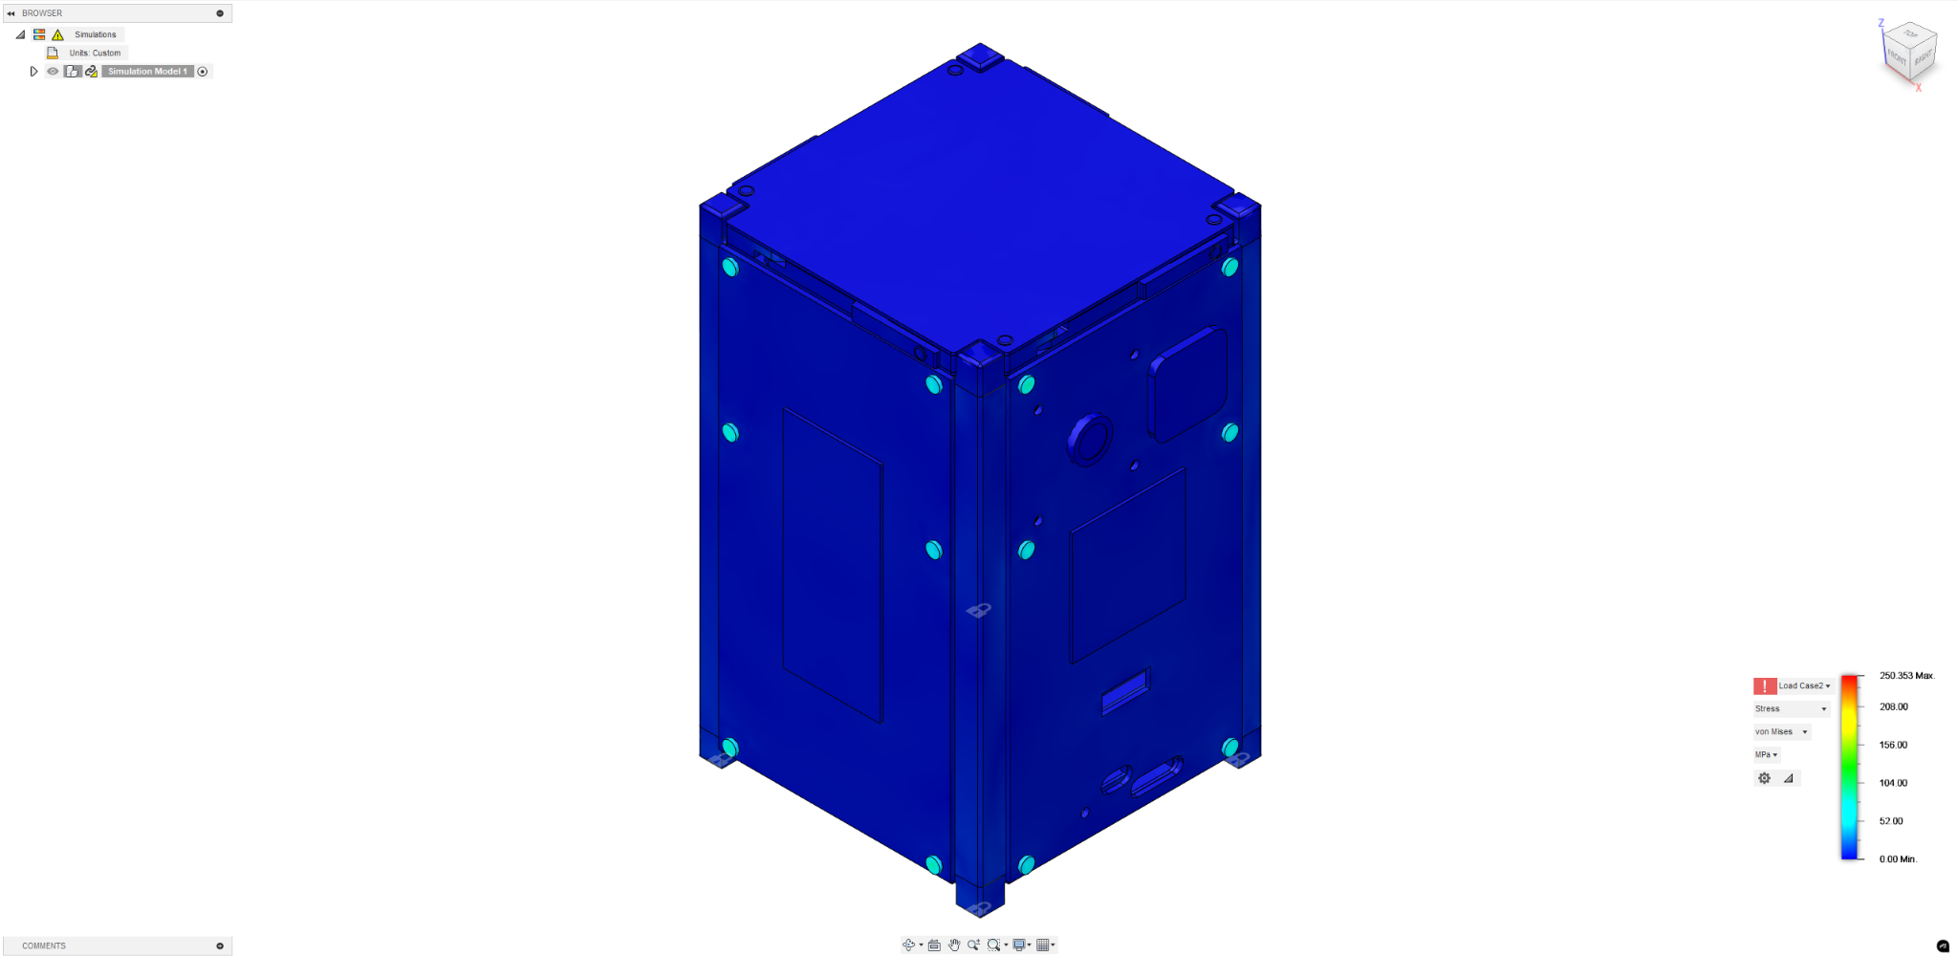
Maximum Von mises stress = 250.353 MPa, Load Case 2

Table. Satellite parts stresses and Margin of Safety (Case 2)

Part | Material | Smax (MPa) | Yield strength (MPa) | Ultimate Strength (MPa) | MS (yield)  FS = 1.5 | MS (Ultimate) FS = 2 | Smax/Ftu (%)< 30%
Str_Base | Al7075 | 75.2 | 480 | 540 | 3.3 | 2.6 | 13.9
Str_Top | Al7075 | 101.8 | 480 | 540 | 2.1 | 1.7 | 18.8
Str_Frame +Y-X | Al7075 | 51.0 | 480 | 540 | 5.3 | 4.3 | 9.5
Str_Frame +Y+X | Al7075 | 61.5 | 480 | 540 | 4.2 | 3.4 | 11.4
Str_Frame -Y+X | Al7075 | 41.9 | 480 | 540 | 6.6 | 5.4 | 7.8
Str_Frame -Y-X | Al7075 | 39.8 | 480 | 540 | 7.0 | 5.8 | 7.4
Spacer Axis | Al6061-T6 | 2.1 | 276 | 310 | 84.7 | 71.2 | 0.7
EPS | Al7075 | 10.6 | 480 | 540 | 29.1 | 24.4 | 2.0
MTQ | Al7075 | 3.2 | 480 | 540 | 98.4 | 82.9 | 0.6
COMM OBC | Al7075 | 3.4 | 480 | 540 | 93.7 | 78.9 | 0.6
Payload | Al7075 | 1.1 | 480 | 540 | 293.1 | 247.2 | 0.2
Antenna | FR4 | 235.2 | 320 | 450 | -0.1 | 0.0 | 52.3
ExtPanel +X | FR4 | 16.8 | 320 | 450 | 11.7 | 12.4 | 3.7
ExtPanel -X | FR4 | 2.9 | 320 | 450 | 72.8 | 76.8 | 0.6
ExtPanel +Y | FR4 | 2.5 | 320 | 450 | 85.5 | 90.2 | 0.5
ExtPanel -Y | FR4 | 2.2 | 320 | 450 | 97.9 | 103.4 | 0.5
ExtPanel -Z | FR4 | 1.7 | 320 | 450 | 121.6 | 128.3 | 0.4
Spacer | Al6061-T6 | 4.0 | 276 | 310 | 45.0 | 37.7 | 1.3

Case 3
The Maximum Von mises stress = 250.021 MPa. The stress distribution in the satellite parts is shown below.
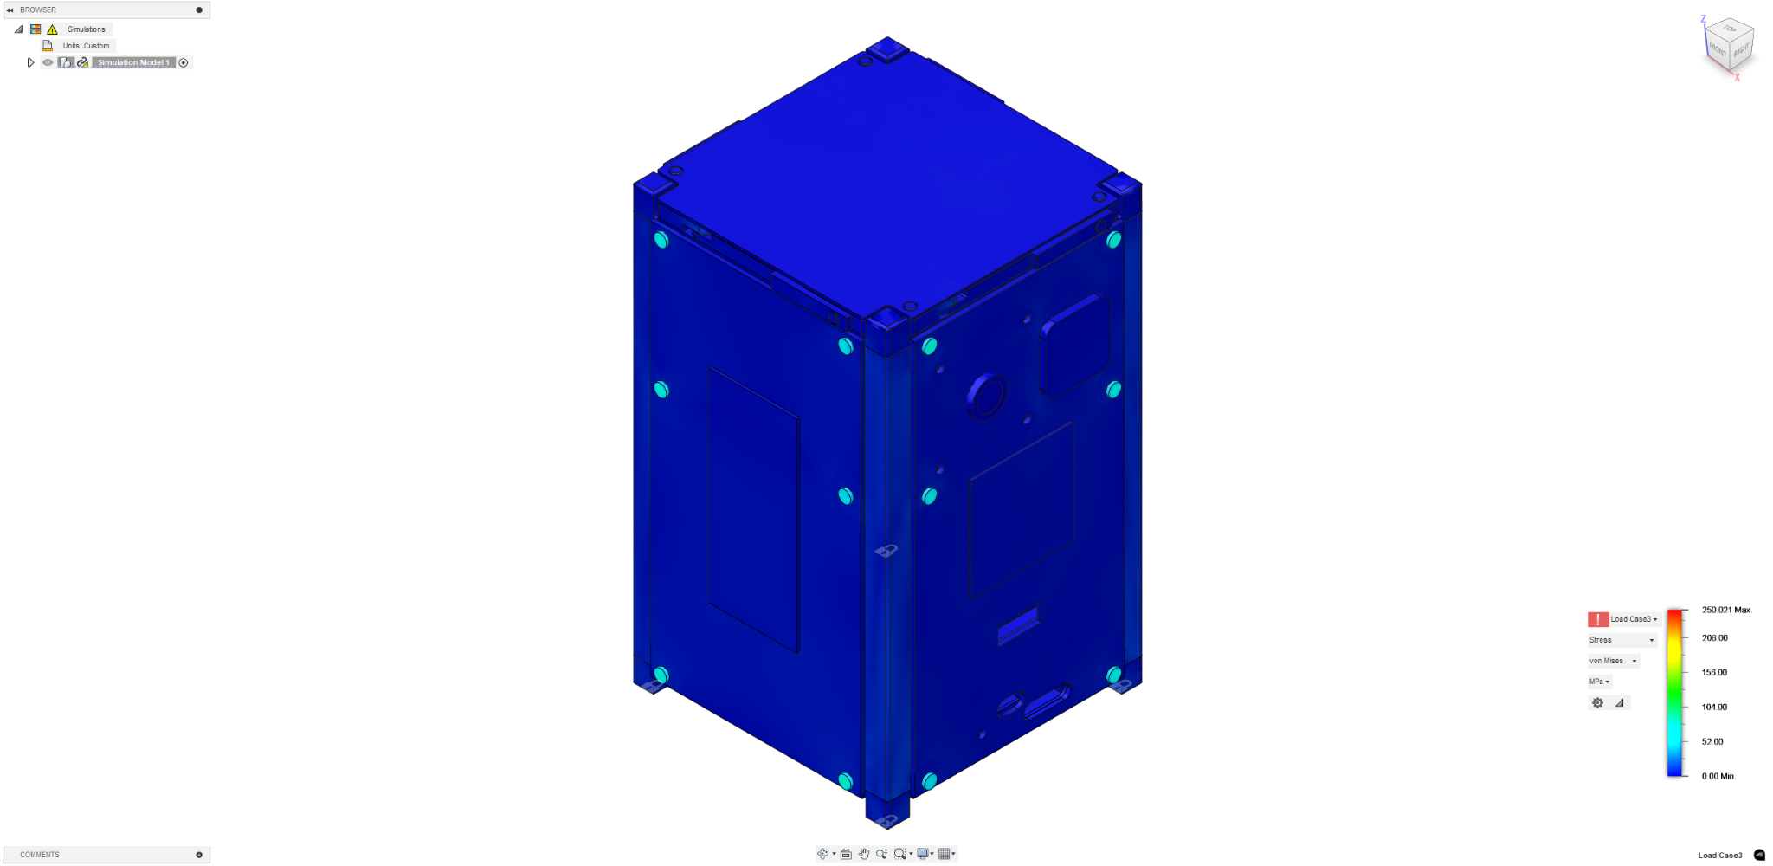

Maximum Von mises stress = 250.021 MPa

Table. Satellite parts stresses and Margin of Safety (Case 3)

Part | Material | Smax (MPa) | Yield strength (MPa) | Ultimate Strength (MPa) | MS (yield)  FS = 1.5 | MS (Ultimate) FS = 2 | Smax/Ftu (%)< 30%
Str_Base | Al7075 | 74.7 | 480 | 540 | 3.3 | 2.6 | 13.8
Str_Top | Al7075 | 101.6 | 480 | 540 | 2.1 | 1.7 | 18.8
Str_Frame +Y-X | Al7075 | 51.2 | 480 | 540 | 5.2 | 4.3 | 9.5
Str_Frame +Y+X | Al7075 | 62.2 | 480 | 540 | 4.1 | 3.3 | 11.5
Str_Frame -Y+X | Al7075 | 41.8 | 480 | 540 | 6.7 | 5.5 | 7.7
Str_Frame -Y-X | Al7075 | 40.0 | 480 | 540 | 7.0 | 5.8 | 7.4
Spacer Axis | Al6061-T6 | 2.7 | 276 | 310 | 67.3 | 56.6 | 0.9
EPS | Al7075 | 20.2 | 480 | 540 | 14.9 | 12.4 | 3.7
MTQ | Al7075 | 2.6 | 480 | 540 | 120.5 | 101.5 | 0.5
COMM OBC | Al7075 | 5.4 | 480 | 540 | 58.4 | 49.1 | 1.0
Payload | Al7075 | 1.6 | 480 | 540 | 200.0 | 168.6 | 0.3
Antenna | FR4 | 235.2 | 320 | 450 | -0.1 | 0.0 | 52.3
ExtPanel +X | FR4 | 14.1 | 320 | 450 | 14.1 | 15.0 | 3.1
ExtPanel -X | FR4 | 2.9 | 320 | 450 | 72.6 | 76.6 | 0.6
ExtPanel +Y | FR4 | 2.7 | 320 | 450 | 79.2 | 83.6 | 0.6
ExtPanel -Y | FR4 | 2.2 | 320 | 450 | 95.3 | 100.6 | 0.5
ExtPanel -Z | FR4 | 1.7 | 320 | 450 | 121.8 | 128.5 | 0.4
Spacer | Al6061-T6 | 6.1 | 276 | 310 | 29.4 | 24.6 | 2.0

Fastener Numbering

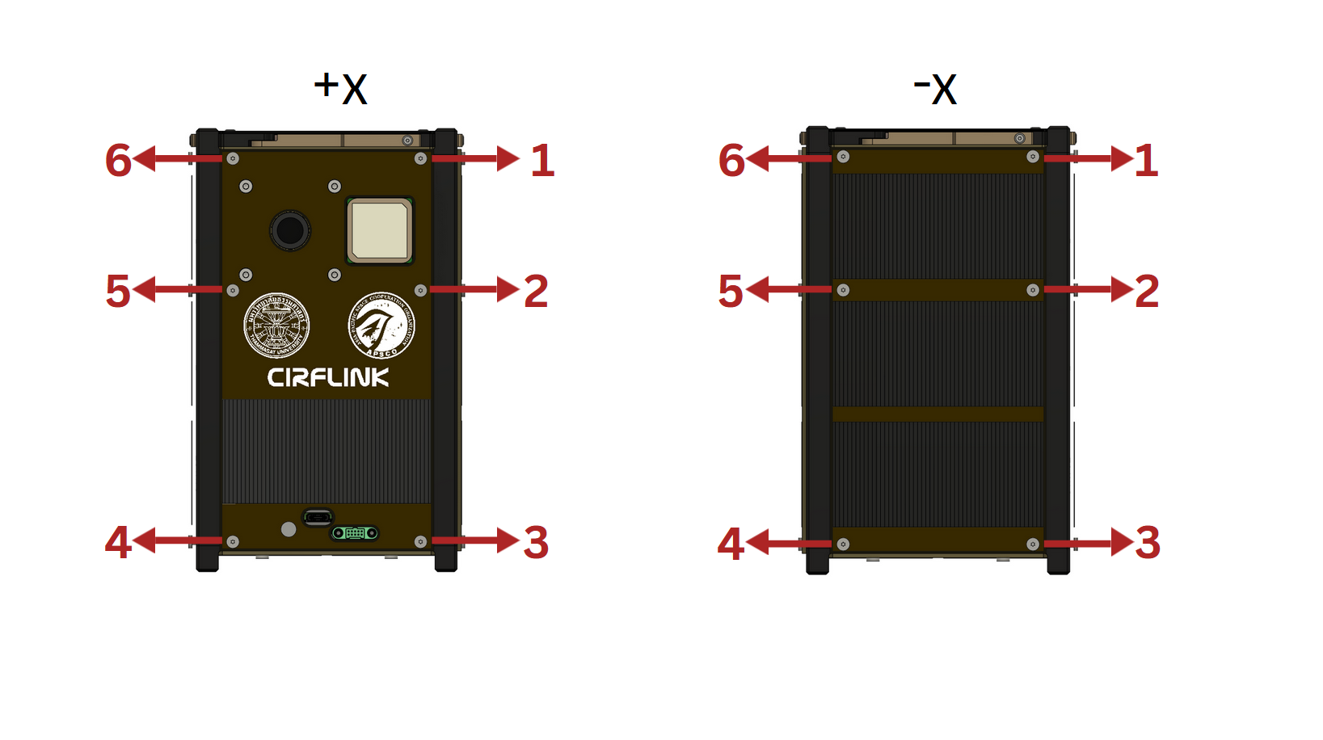
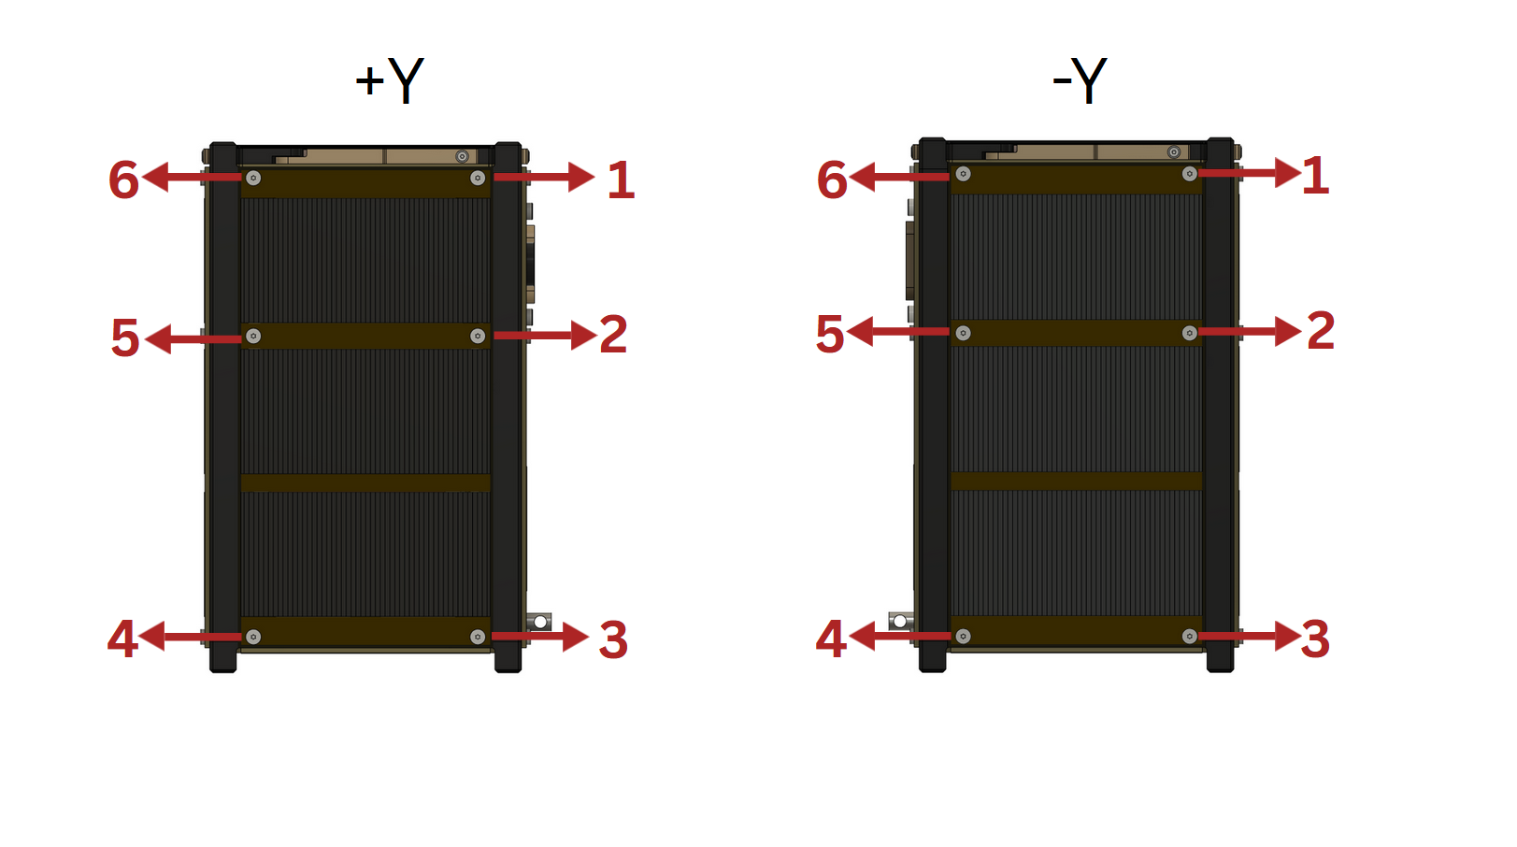

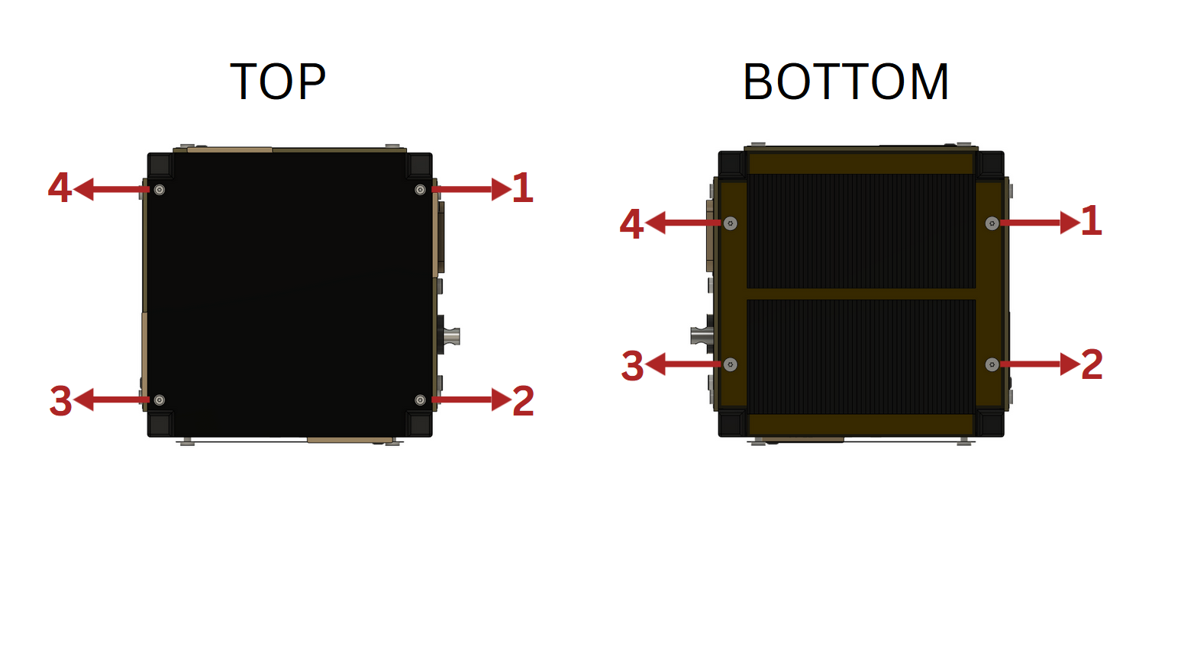
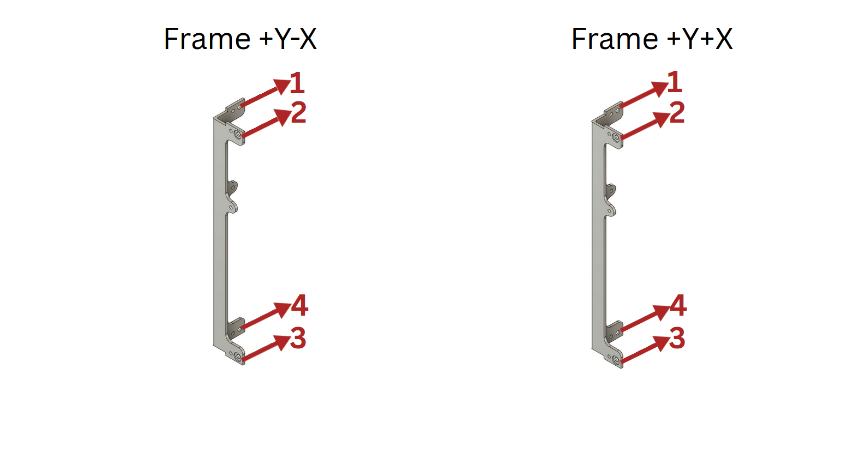

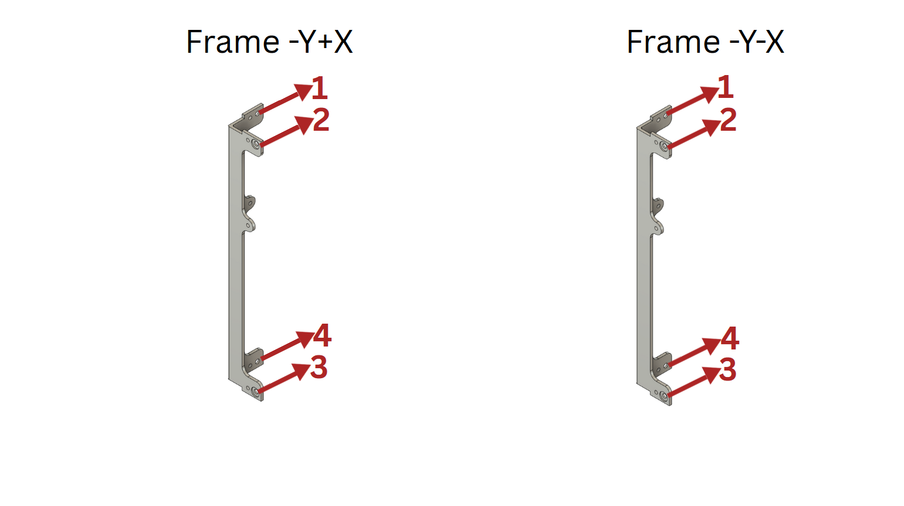

Nominal Fastener Analysis
Table of Fastener Groups
 | Group | Fastener | Material/ Grade | Ultimate Strength | Qty | Remarks
1 | Ext Panel +X | SSTS-M2.5-5 | SUS304 | 520 MPa | 6
2 | Ext Panel -X | SSTS-M2.5-5 | SUS304 | 520 MPa | 6
3 | Ext Panel +Y | SSTS-M2.5-5 | SUS304 | 520 MPa | 6
4 | Ext Panel -Y | SSTS-M2.5-5 | SUS304 | 520 MPa | 6
5 | Ext Panel -Z | SSTS-M2.5-5 | SUS304 | 520 MPa | 4
7 | Str Frame +Y-X | CBSTSR2.5-3 | SUS304 | 520 MPa | 6
8 | Str Frame +Y+X | CBSTSR2.5-3 | SUS304 | 520 MPa | 6
9 | Str Frame -Y+X | CBSTSR2.5-3 | SUS304 | 520 MPa | 6
10 | Str Frame -Y-X | CBSTSR2.5-3 | SUS304 | 520 MPa | 6
11 | Antenna | SSTS-M2.5-8 | SUS304 | 520 MPa | 8
12 | Antenna | CBSTSE2-6 | SUS304 | 520 MPa | 4

Case 1
S/N | Group | Stress (MPa) | Ultimate strength(MPa) | Margin of Safety (FS = 2) | Screw with Max Stress | Nominal Fastener Qty | NDE required?
1 | Ext Panel Ant | 235.19 | 520 | 0.1 | 1 | 8 | No
2 | Ext Panel -Z | 217.15 | 520 | 0.2 | 1 | 4 | No
3 | Ext Panel +Y | 250.18 | 520 | 0.0 | 1 | 6 | No
4 | Ext Panel -Y | 228.28 | 520 | 0.1 | 1 | 6 | No
5 | Ext Panel +X | 228.78 | 520 | 0.1 | 1 | 6 | No
6 | Ext Panel -X | 229.33 | 520 | 0.1 | 1 | 6 | No
7 | Str Frame +Y-X | 245.02 | 520 | 0.1 | 1 | 6 | No
8 | Str Frame +Y+X | 248.81 | 520 | 0.0 | 1 | 6 | No
9 | Str Frame -Y+X | 247.95 | 520 | 0.0 | 1 | 6 | No
10 | Str Frame -Y-X | 245.59 | 520 | 0.1 | 1 | 6 | No

Case 2
S/N | Group | Stress (MPa) | Ultimate strength(MPa) | Margin of Safety(FS = 2) | Screw with Max Stress | Nominal Fastener Qty | NDE required?
1 | Ext Panel Ant | 235.16 | 520 | 0.1 | 1 | 4 | No
2 | Ext Panel -Z | 217.11 | 520 | 0.2 | 1 | 4 | No
3 | Ext Panel +Y | 250.35 | 520 | 0.0 | 1 | 6 | No
4 | Ext Panel -Y | 228.28 | 520 | 0.1 | 1 | 6 | No
5 | Ext Panel +X | 228.89 | 520 | 0.1 | 1 | 6 | No
6 | Ext Panel -X | 229.52 | 520 | 0.1 | 1 | 6 | No
7 | Str Frame +Y-X | 244.49 | 520 | 0.1 | 1 | 6 | No
8 | Str Frame +Y+X | 248.01 | 520 | 0.0 | 1 | 6 | No
9 | Str Frame -Y+X | 248.34 | 520 | 0.0 | 1 | 6 | No
10 | Str Frame -Y-X | 246.61 | 520 | 0.1 | 1 | 6 | No

Case 3
S/N | Group | Stress (MPa) | Ultimate strength(MPa) | Margin of Safety (FS = 2) | Screw with Max Stress | Nominal Fastener Qty | NDE required?
1 | Ext Panel Ant | 235.25 | 520 | 0.1 | 1 | 4 | No
2 | Ext Panel -Z | 217.10 | 520 | 0.2 | 1 | 4 | No
3 | Ext Panel +Y | 249.44 | 520 | 0.0 | 1 | 6 | No
4 | Ext Panel -Y | 228.66 | 520 | 0.1 | 1 | 6 | No
5 | Ext Panel +X | 228.94 | 520 | 0.1 | 1 | 6 | No
6 | Ext Panel -X | 229.41 | 520 | 0.1 | 1 | 6 | No
7 | Str Frame +Y-X | 245.99 | 520 | 0.1 | 1 | 6 | No
8 | Str Frame +Y+X | 250.02 | 520 | 0.0 | 1 | 6 | No
9 | Str Frame -Y+X | 247.17 | 520 | 0.1 | 1 | 6 | No
10 | Str Frame -Y-X | 247.15 | 520 | 0.1 | 1 | 6 | No

Summary of Nominal Fastener Analysis

S/N | Case | Max stress (MPa) | Ultimate strength (MPa) | MS (FS = 2) | Screw ID with Max stress
1 | Case 1 | 250.18 | 520 | 0.0 | Ext Panel +Y
2 | Case 2 | 250.35 | 520 | 0.0 | Ext Panel +Y
3 | Case 3 | 250.02 | 520 | 0.0 | Str Frame +Y+X

Conclusion
The structural analysis of CIRFLINK shows that all parts meet the fracture control requirements.

